

NEW JERSEY INSTITUTE OF TECHNOLOGY
SCHOOL OF APPLIED ENGINEERING AND TECHNOLOGY

TEAM NUMBER | 1
SUBMITTED TO | Professor Hansis
SUBMITTED BY | Joshua Chary (and Shival Panchal)
COURSE NAME\NUMBER\SECTION | ECET 230
EXPERIMENT | Personal Weather Station
DATE | 5/6/2026

Introduction:
The goal of this project was to create a personalized weather station using a custom PCB and embedded system design. The system was designed to monitor environmental conditions in real time, including temperature, humidity, and atmospheric pressure. Along with building a useful monitoring device, the project focused on learning the full PCB design workflow, including schematic capture, component selection, PCB layout, design rule checks, manufacturing file preparation, and design revision.
The final design uses an ATmega328P-A microcontroller as the main processing unit and a BME280 environmental sensor to collect temperature, humidity, and barometric pressure data. The project changed throughout development. The original proof of concept used a DHT22 sensor and a Raspberry Pi-style GUI approach, but the final direction moved toward a smaller custom PCB using the BME280, USB serial communication, and a Python computer application for graphing, prediction, and phone notifications. This better reflected a realistic product design because the final system does not rely on a bulky Raspberry Pi and touchscreen setup.
During development, several real engineering issues came up, including incorrect BME280 pin labeling, damaged sensor modules, missing support components during PCB review, routing limitations, power input decisions, and USB communication decisions. These problems helped improve the design because each issue forced the team to review, troubleshoot, and make better design choices. The final result is a compact manufacturable embedded weather station design that demonstrates hardware/software integration and the full PCB development process.

Updated Project Definition:

High-Level Description
The Personalized Weather Station is a compact embedded environmental monitoring system designed to collect real-time weather data and send it to a user-facing computer application. The system measures temperature, humidity, and atmospheric pressure using a BME280 sensor connected to an ATmega328P-A microcontroller. The board communicates with a computer over USB serial communication, where a Python program receives the data, graphs the readings, estimates short-term trends, classifies the weather condition, and can send phone notifications through ntfy.
The project also serves as a full PCB design exercise. It includes schematic design, PCB routing, BOM generation, manufacturing file preparation, debugging, and documentation. The design is intended to be manufacturable and expandable for future features such as improved prediction, app integration, wireless communication, cloud logging, and enclosure development.

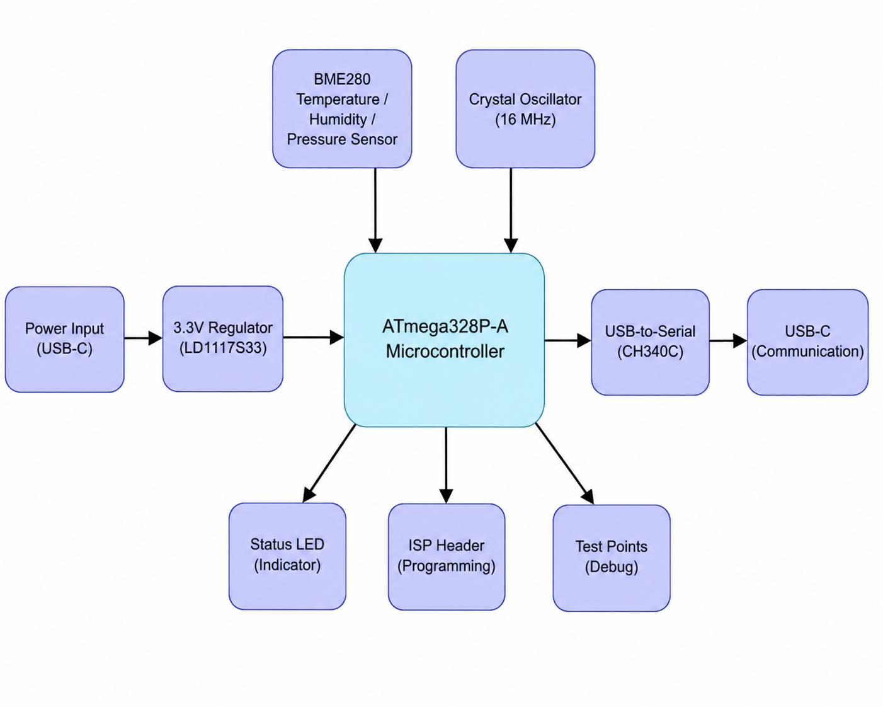

Purpose
The purpose of the project is to design a smaller and more personalized alternative to oversized weather monitoring systems while also gaining practical experience with embedded hardware and PCB manufacturing. The system is meant to collect useful environmental data and display it in a way that is easy for the user to understand.
· Monitor environmental conditions in real time.
· Measure temperature, humidity, and atmospheric pressure.
· Use a custom PCB instead of a full development-board-only setup.
· Practice schematic capture, PCB layout, ERC/DRC checks, BOM creation, and manufacturing preparation.
· Use USB serial communication so a computer program can graph and process the sensor data.
· Explore prediction logic and phone notifications as future-facing product features.

Objectives
· Design a custom PCB for a personalized weather station.
· Use an ATmega328P-A microcontroller as the main embedded controller.
· Use a BME280 sensor for temperature, humidity, and pressure measurement.
· Add the required support circuitry, including reset pull-up, pull-up resistors, crystal oscillator, decoupling capacitors, voltage regulation, USB-C connection, and ISP programming header.
· Create a BOM and prepare the board for manufacturing.
· Validate the concept through testing and demonstration software.
· Use Python to receive USB serial data, graph actual readings, estimate predicted values, classify weather trends, and send ntfy notifications.
· Document design choices, troubleshooting steps, and lessons learned.

System Overview
The system is built around the ATmega328P-A microcontroller. The BME280 sensor collects environmental data and sends it to the microcontroller. The board includes supporting components for stable operation, including an external crystal oscillator, load capacitors, reset circuitry, decoupling capacitors, test points, an ISP programming header, USB-C hardware, a CH340C USB-to-serial interface, and a 3.3 V regulator.
The computer-side Python program connects to the board using USB serial communication. Once connected, it reads temperature, humidity, and pressure values, converts the units, graphs the readings, predicts short-term trends, classifies the weather condition, and sends phone notifications through ntfy during the demo.

Major Components
Component | Purpose | Notes
ATmega328P-A | Main microcontroller | Handles sensor communication, processing, and serial output.
BME280 | Environmental sensor | Measures temperature, humidity, and barometric pressure.
CH340C | USB-to-serial interface | Allows the board to communicate with the computer through USB serial.
USB-C power  USB-C communication | Power/communication interface | Used for connecting the device to the computer; CC resistors support proper USB-C behavior.
LD1117S33TR | 3.3 V voltage regulator | Regulates input voltage down to 3.3 V for the MCU/sensor side of the design.
Crystal Oscillator + 22 pF capacitors | MCU clock circuit | Provides a more stable clock than the internal oscillator.
R1 10 kOhm | Reset pull-up | Keeps the ATmega328P-A out of reset during normal operation.
R2/R3 4.7 kOhm | Communication pull-ups | Support reliable sensor communication lines.
R4 330 Ohm + LED | Status indicator | Provides a simple visual indication when the output pin is active.
C1/C5/C6/C7 0.1 uF, C2 10 uF | Decoupling/bulk capacitance | Helps stabilize power and reduce noise.
J2 ISP Header | Programming connector | Used to flash firmware onto the ATmega328P-A.
TP1-TP4 | Test points | Allows probing of signals and ground during testing/debugging.

Actual Development Path
The project did not stay exactly the same as the original proposal. The original concept mentioned a Raspberry Pi 4, DHT22, GUI display, and future BME280 pressure integration. What actually happened was that the DHT22 was used only as an early proof of concept, and the project moved to the BME280 because it measures temperature, humidity, and pressure in one sensor. The Raspberry Pi/touchscreen-style product idea was also moved away from because it was too large and expensive for a realistic weather station product.
The final direction became a custom PCB with an ATmega328P-A and BME280, connected to a computer by USB serial. The computer application handles the higher-level user interface, graphing, prediction, and phone notifications. This approach keeps the physical product smaller and closer to a real embedded product while still allowing the demo to show live data clearly.

Testing and Demonstration
Testing focused on proving that the sensing and data processing concept worked and that the PCB design was manufacturable. The BME280 sensor was used to collect environmental data. The Python program received serial data from the device, displayed a simple Tkinter interface, plotted live data using Matplotlib, predicted short-term trends, classified weather behavior, and sent ntfy notifications. The demonstration showed how the user could plug the device into a computer, run the application, and see weather readings and predictions update automatically.
The Python program used a fixed serial port setting for the demo, read comma-separated temperature, humidity, and pressure data, converted Celsius to Fahrenheit, converted pressure from hPa to inHg, graphed actual and predicted values, and sent phone notifications on a cooldown. This made the software useful for showing the project even before a final polished application was created.

Troubleshooting and Design Challenges
· The original proof of concept used a DHT22 because it was available and easy to start with, but it was later dropped once the BME280 worked.
· Some BME280 modules were damaged during early testing because the pins were incorrectly labeled or misidentified, causing wiring mistakes.
· The initial PCB layout needed review because missing decoupling/bulk capacitors and other support details had to be added.
· Test points were added so important signals and ground could be probed during validation.
· USB-C communication was chosen instead of adding Wi-Fi hardware because the project did not need wireless hardware on the PCB for the current demo.
· A CH340C USB-to-serial interface was included so the board could communicate with the computer application.
· A 3.3 V voltage regulator was included because the sensor and MCU side needed a stable lower-voltage supply.
· The design was implemented as a 4-layer board to better understand layer stackups, vias, and inner-layer routing, even though the project started from a simpler PCB approach.
· The final product direction moved away from Raspberry Pi plus touchscreen because that approach was too bulky and costly for the intended product.

User Documentation:

Product Purpose
The Personalized Weather Station is a compact PCB-based environmental monitoring device. It measures temperature, humidity, and barometric pressure using a BME280 sensor. The board sends the data to a computer through USB serial communication, and the computer application displays the readings, graphs the data, predicts short-term trends, and can send phone notifications.

How to Operate
1. Connect the dedicated USB-C power connection and USB-C communication connection.
2. Open the weather station computer application.
3. Start monitoring in the application.
4. The device will send sensor readings through USB serial communication.
5. The application will graph the readings and display the predicted weather trend.
6. Phone notifications may be sent through ntfy during demo operation.

User Interface Elements
- USB-C power connection: provides power to the PCB.
- USB-C communication connection: transfers USB serial data between the PCB and computer application.
- Computer application: shows monitoring status, plots live readings, and displays the weather prediction.
- Phone notification: sends weather updates through ntfy when the software triggers a message.
- Status LED: provides a simple visual indicator when the assigned output pin is active.
- ISP header: used only for programming the ATmega328P-A, not for normal user operation.
- Test points: used for engineering validation and troubleshooting, not for normal user interaction.

External Connections Summary
Connection | Location | Purpose
DualUSB-C Power Port | J1 | Dedicated board power input
USB-C Communication Port | J3 | USB serial communication with computer
ISP Programming | J2 | Firmware flashing for the ATmega328P-A.
Test Points | TP1-TP4 | Signal and ground probing during validation.
Battery/External Power Option | Battery holder or USB C | portable or external power source depending on final build configuration.

Design Decision Document:

1. Primary Sensor Selection - DHT22 to BME280
The project started with the DHT22 because it was available and worked for a quick proof of concept. However, the DHT22 only measures temperature and humidity. The BME280 was selected for the final design because it measures temperature, humidity, and barometric pressure in one compact sensor package. The BME280 also better supports the weather prediction goal because pressure trends are important for classifying changing weather conditions.

2. Microcontroller Selection - ATmega328P-A
The ATmega328P-A was selected because it is well documented, familiar, and appropriate for a compact embedded system. Instead of placing a full Arduino board inside the product, the bare microcontroller was integrated into the PCB. This makes the design smaller and more realistic for a manufacturable embedded product.

3. Communication to Computer - USB Serial
USB serial communication was chosen because the current product does not need Wi-Fi hardware on the PCB. A USB connection allows the user to plug the device into a computer, run the application, collect data, and show live graphs. This is simpler and more reliable for the class demo than adding an ESP module or a full wireless system.

4. USB-to-Serial Interface - CH340C
The CH340C was included so the ATmega328P-A can communicate with the computer over USB serial. This supports the actual demo workflow, where the Python application receives sensor readings through a COM port and handles graphing, prediction, and notifications.

5. Voltage Regulation - 5 V to 3.3 V
A 3.3 V regulator was added because the BME280 and low-voltage logic side need a stable 3.3 V supply. This also helps protect the sensor and makes the board safer and more predictable when powered from USB or another input source.

6. Output Method - Computer Application and Phone Notifications
The original Raspberry Pi/touchscreen idea was dropped because it made the product too bulky and expensive. The final demo uses a computer application to show graphs and predictions, and ntfy notifications to send alerts to a phone. This is more practical than building a full display into the hardware.

7. PCB Layer Count - 4-Layer Learning Exercise
The project started with normal PCB routing, but the design was implemented as a 4-layer board to learn more about stackups, routing on inner layers, and via management. This was valuable because it showed how a real board can be improved and organized beyond a simple 2-layer layout.

8. Support Components
Support components were added to make the design stable and complete. These included the reset pull-up resistor, communication pull-ups, LED current-limiting resistor, decoupling capacitors, bulk capacitor, crystal oscillator, load capacitors, test points, ISP programming header, USB-C hardware, and voltage regulator. Several of these parts were added or corrected after design review, which made the final design stronger.

Manufacturing Readiness
The PCB design includes the main schematic, board layout, BOM, and manufacturing-oriented files. The design uses commercially available components, including the ATmega328P-A, BME280, CH340C, dedicated USB-C power, dedicated USB-C communication, LD1117 3.3 V regulator, passives, crystal, test points, LED, and programming header. Gerber and drill files are separate manufacturing outputs: Gerbers describe the copper, mask, silkscreen, and board layers, while drill files describe the holes and vias. Both are needed by the PCB manufacturer.
The board was prepared to be manufacturing-ready, but the project should still be treated as an educational prototype until it is physically fabricated, assembled, and fully validated. The test points and programming header make future validation easier after assembly.

Individual Contributions - Joshua Chary:
· Project documentation and updated project definition.
· Development logging and explanation of what changed from the original idea.
· PCB review assistance and identifying missing or unclear design elements.
· BOM review and component/function clarification.
· Troubleshooting documentation, including sensor issues, USB communication decisions, and power/regulator decisions.
· Presentation preparation and explanation of design challenges.
· Helping connect the technical design choices to what the product actually does for the user.

Future Improvements:
· Fabricate and assemble the PCB, then validate it with real measurements.
· Create a cleaner final desktop application or mobile app.
· Improve prediction logic using a better regression model and more collected data.
· Add optional cloud logging or data export.
· Design a custom enclosure.
· Add waterproofing or outdoor-rated sensor placement.
· Improve power management for battery operation.
· Consider wireless communication in a future revision only if the product needs standalone remote operation.
Schematic: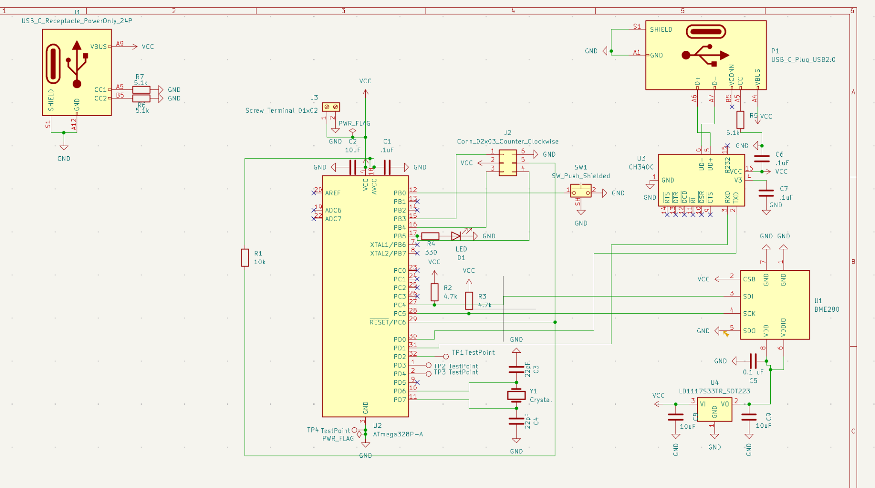

ERC/DRC Readings:
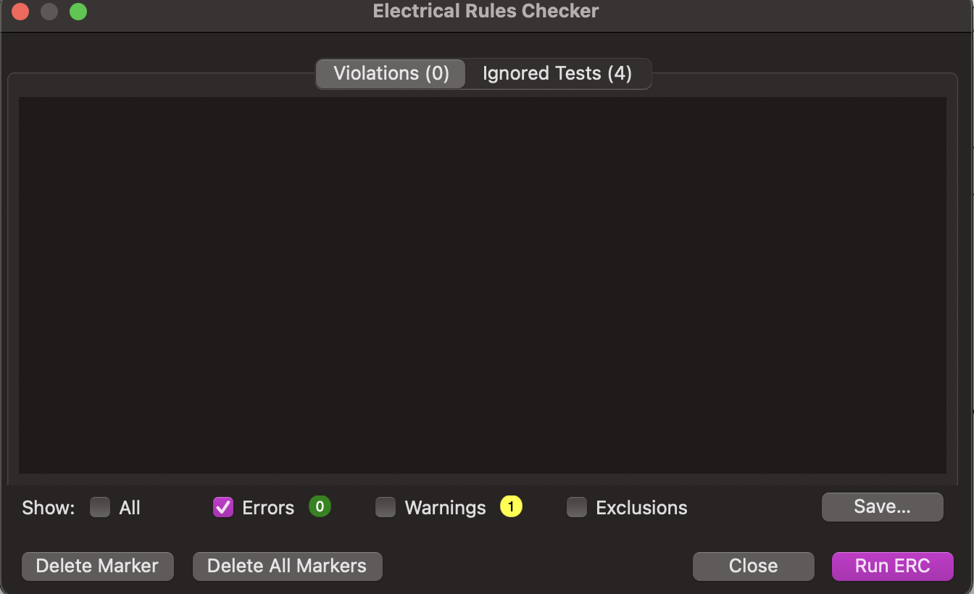
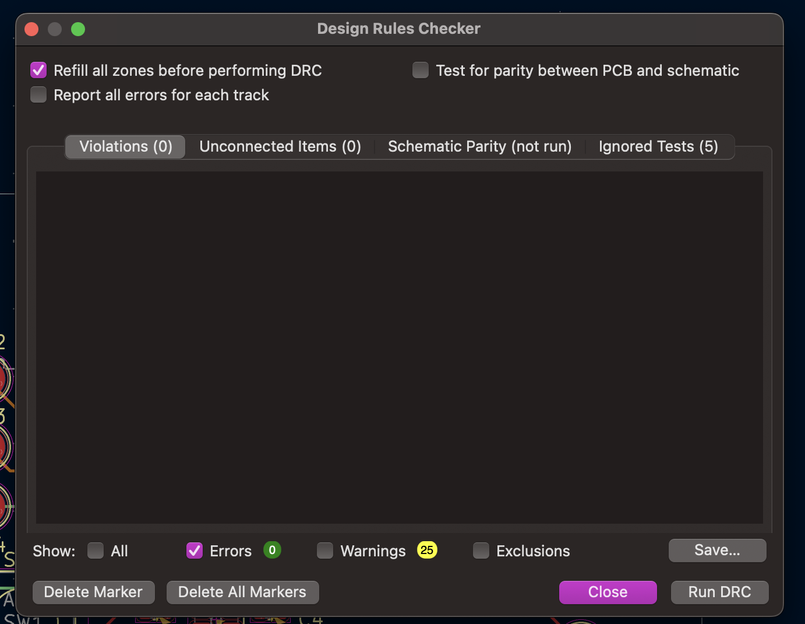

3D Board Renderings:
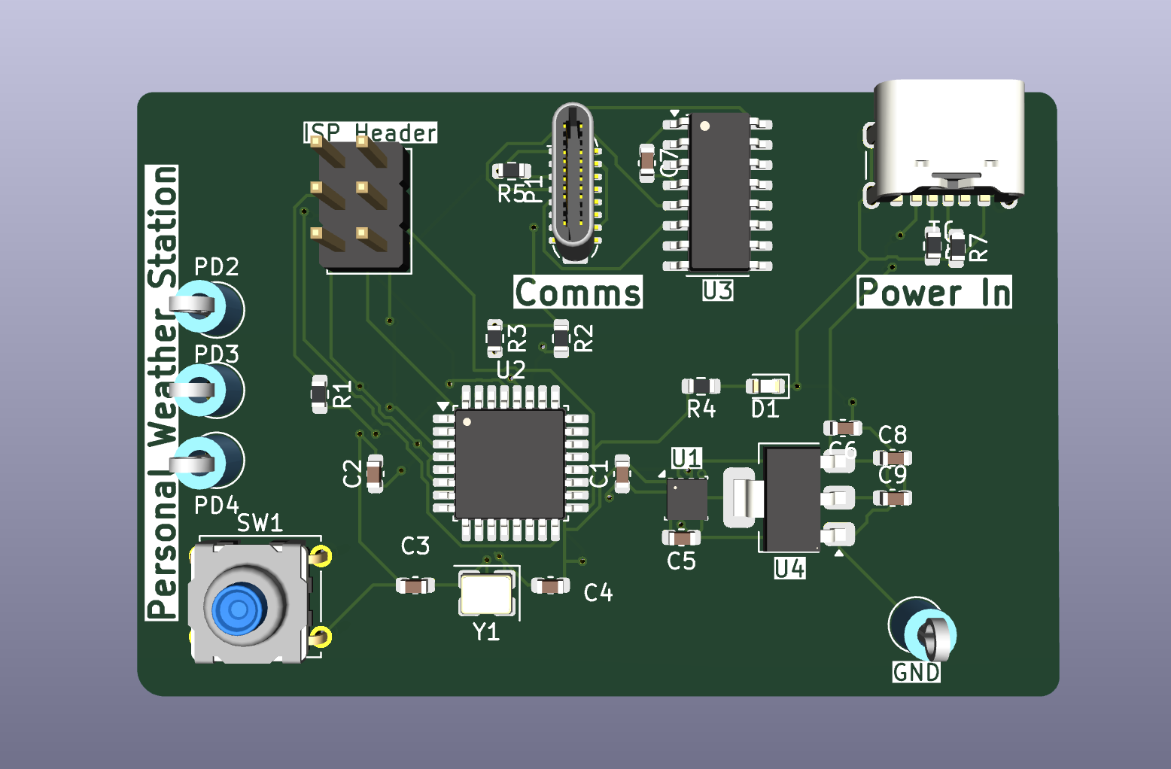
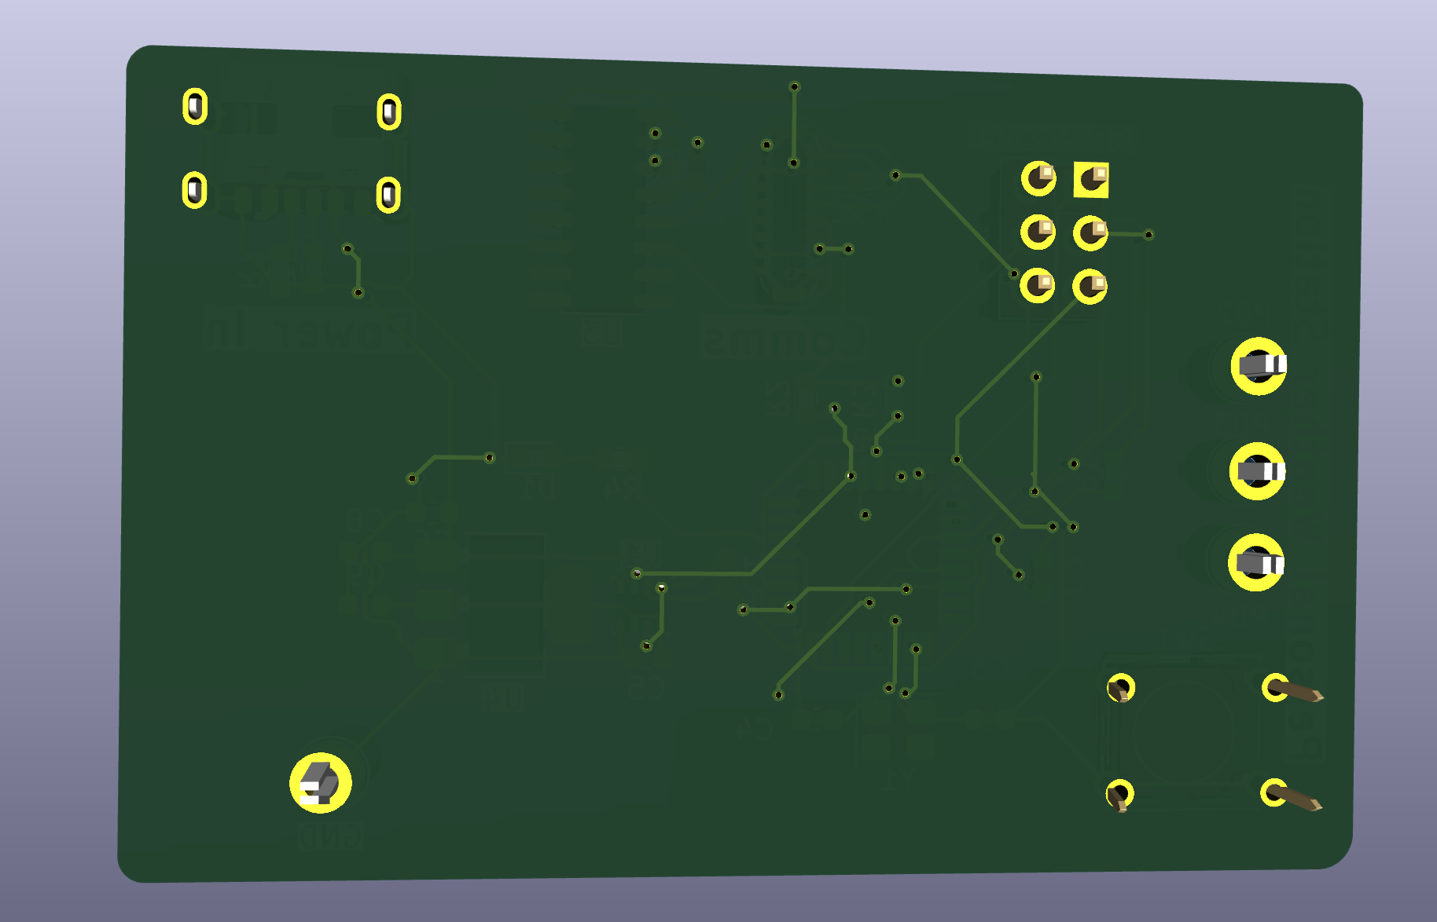

Conclusion
The Personalized Weather Station successfully evolved from a simple proof-of-concept idea into a more realistic custom PCB-based embedded system. The project started with a DHT22/Raspberry Pi-style concept, but the final direction used an ATmega328P-A, BME280 sensor, USB serial communication, Python graphing, prediction logic, and phone notifications. The project gave hands-on experience with real engineering challenges, including damaged sensors, incorrect pin labeling, PCB review, missing support components, USB communication decisions, and voltage regulation. Overall, the final design better reflects what actually happened during development and provides a strong foundation for a manufacturable weather monitoring product.

